
Springcroft Primary School

Assessment Policy

Date Adopted: September 2025
Author/owner: Springcroft Primary School
Anticipated Review: Autumn Term 2027

Approved | Signature | Date

Our Mission Statement:
The place to learn, the place to succeed, the place to make friends, the place to grow.

Introduction
At Springcroft Primary School we endeavour to support all pupils in making better than expected progress and raise confidence and self-esteem. We see assessment as central to this. This includes:
- Teacher marking work and feedback
- Observations and Group Work
- Formal Summative Assessments (Including Statutory National Tests, NFER test, White Rose Maths end of unit tests)
- Weekly Spelling Tests
This policy is written in line with all subject based policies and our Feedback Policy. This is a working document and changes to policy reflect current practice.
Aims
- To ensure children progress, knowing their achievements and what they need to do next.
- To internally track pupils for attainment and progress.
- To ensure teacher planning is amended in order that the teaching and learning meet the needs of all children
- To have a consistent approach that measures school progress against national standards.
Why Assess?
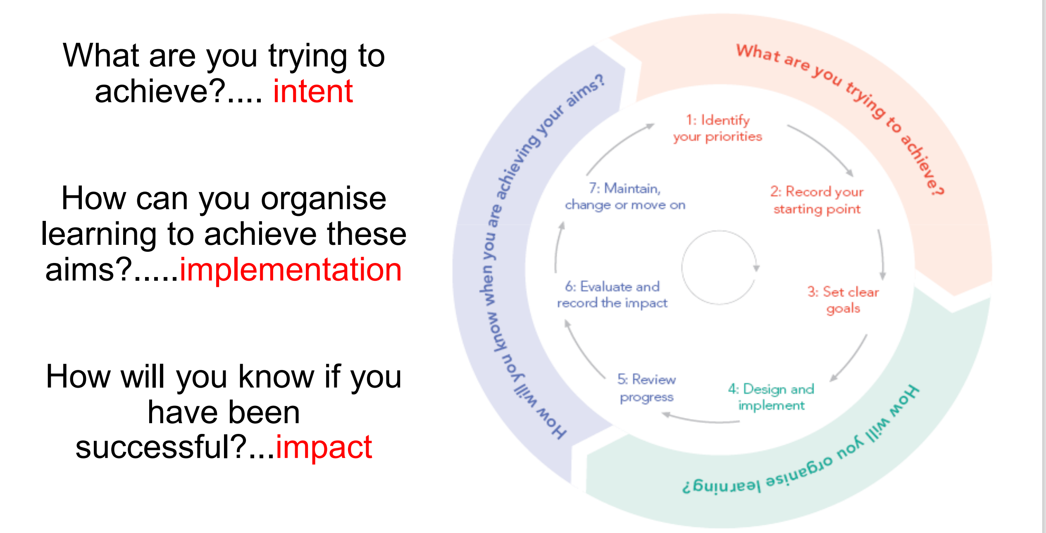
Principles
Springcroft Primary School employs a range of assessment strategies to celebrate pupil’s current level of learning and to identify their next steps:

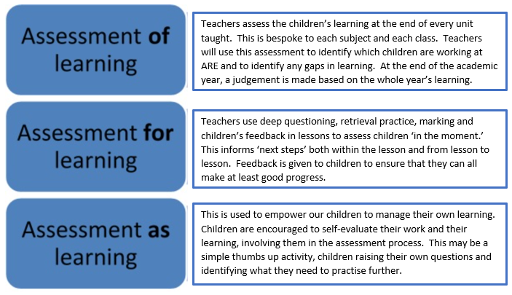
These different approaches to assessment are delivered through three main types of assessment; summative, interim and formative assessment:
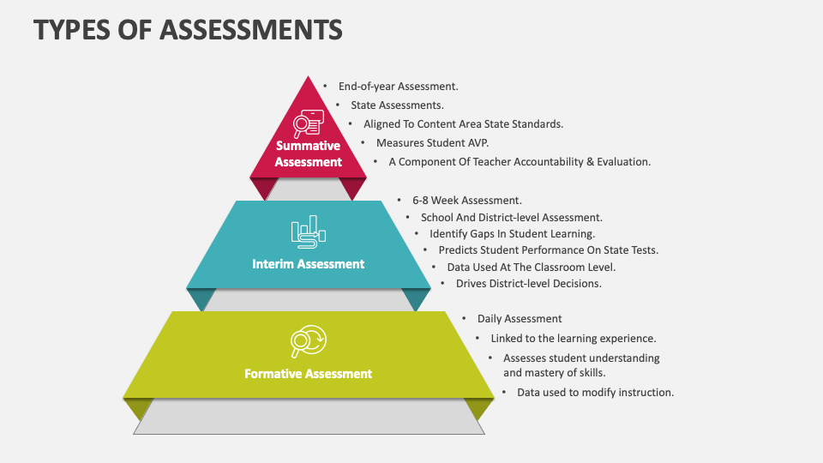
- Assessment of children can take different forms including questioning, test, quick recall, “explain it again”, retrieval activities, observations, discussions and learners being able to apply a concept in a different context. This is in addition to the formal assessment of written work and tests.
- Every term, pupils across school are formally assessed and their outcomes (data) are tracked. This is then provided to parents and carers at termly progress meetings. Each half term, pupil progress meetings take place to ensure children continue to be challenged in their learning.
- As well as feedback, formal assessment procedures are carried out in order to support the on-going teacher assessment of pupils.
What are we assessing?
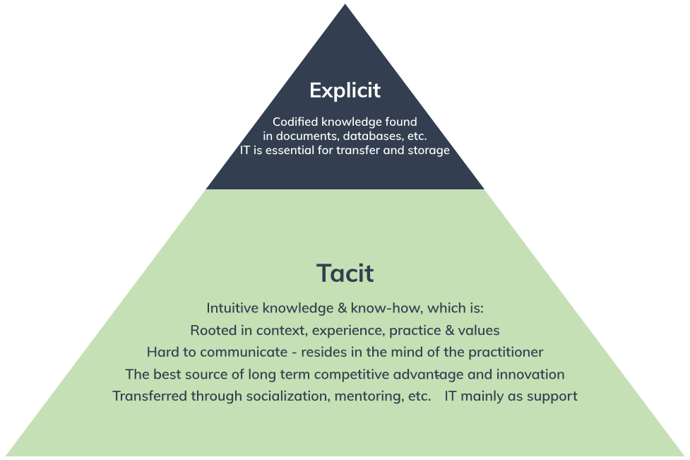

Teacher Assessment
On-going teacher assessment is central to pupils making at least expected progress. All pupil’s data is recorded which shows knowledge and attainment towards standards in core subjects (reading, writing and mathematics) and foundation subjects. Assessments and observations are completed on a regular basis by staff and used to inform the planning of next steps. Marking of work, discussions and observations inform the on-going assessments of pupil’s skills and knowledge.
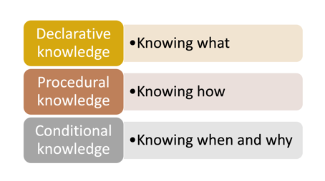
Teacher assessments are moderated alongside colleagues within school, across the cluster and with external partners. At the end of each year, teachers share this information as part of our transition arrangements.
Class teachers and subject leaders use Questioning Grids when planning learning and monitoring teaching and learning to develop higher level thinking skills (See Appendix 1)
Special Educational Needs
Pupils identified on the SEN register are assessed in line with other pupils using the Springcroft grades. Where appropriate, staff use standardised tests from other year groups to support the on-going teacher assessment of pupils.
Assessment with the Early Years
Evidence is collected through observation and discussion and this is recorded in pupils’ learning journeys. Photographic and video evidence is also collected along with pupil quotations. As well as written work, these form the basis of the on-going teacher assessments in line with Age Related Expectations. Phonics assessments are completed half-termly using the Little Wandle Letters and Sounds assessments, and any children completing a catch up/intervention group receive assessments every 3 weeks.
Evidence that a child is secure will be found:
- In children’s individual exercise books
- On “Evidence Me” (online secure evidencing database) which is facilitated using school devices only.
- Through formal testing
  - National EYFS Baseline assessments
Staff report and analyse this data termly, and this is reported to Governors through the Headteacher’s Report to Governors. Assessments provide staff within the EYFS with intervention target groups in order to accelerate progress. Data is provided to parents and carers at the end of each year.
Assessment in Key Stage1 and 2 (English and Mathematics)
Along with on-going teacher assessment, more formal assessments are carried out prior to each half-term or end of term holiday. A data tracking system is used in school to inform teacher assessments. Children in KS1 who are still accessing phonics complete the Little Wandle Letters and Sounds assessments 3 weekly.
Evidence that a child is secure will be found:
- In children’s individual exercise books
- Through formal testing
  - End of unit maths White Rose Maths assessments in mathematics
  - End of term assessments in White Rose Maths in mathematics
  - End of year NFER assessments in mathematics
  - End of term NFER assessments in reading in Y3-Y6
  - End of term NFER assessments in Grammar, Punctuation and Spelling (GPS) in Y3-Y6
  - Suffolk Reading Age scores in Jan and July
  - Termly writing assessments are moderated “in house” and within our cluster partners.
- Teacher professional judgement (retrieval practise, in the moments assessment)
We aim to have every child to ‘secure +’ by the end of each academic year. However, as long as they are ‘secure’, they will have covered enough of the curriculum for them to be able to access the next year’s units of work. If a child is not making sufficient progress, this will be picked up before the end of the Autumn term and interventions will be put in place to support their learning. If a child has a SEN they may be working at a different level to the class but progress will be monitored through our number system. Children will be expected to make 3 steps per year. 4 steps is good and 5+ is outstanding (see Appendix 2).
Teacher assessments are entered on to the schools tracking system (DCPro) and progress maps created to show attainment and progress against targets.
This data is analysed to show Average Points Score Progress and to identify groups and individuals who may require further intervention and those who are making accelerated progress.
Targets for pupils are set at the start of each year and discussed during Pupil Progress Meetings throughout the year. These targets are linked to staff appraisal.
The data analysis informs the SIP and SEF documentation and drives forward staff training and support packages within school.
National Standardised Tests are carried out in Year 1 (phonics screening), Year 4 (multiplication times tables check/MTC) and Year 6 (Key Stage 2 Assessments/SATS). The school uses commercially available testing in Year 3, 4 and 5 to give a standardised score.
Individual assessment data is shared with parents and carers at parental meetings and in pupils’ annual reports.
Assessment Within Curriculum Subject Areas
Although pupils are not formally assessed in foundation subjects, we believe it is vital for them to know how they are doing in order to make progress. Levels for foundation subjects are reported at the end of year and identify if children are working towards the expected standard or are working at the expected standard. This also helps staff to see gaps in learning and they adapt their planning accordingly.
To asses the foundation subjects, we use a layered approach to assessment with clearly identified end-points. The layered approach begins with Assessment For Learning in lessons which is facilitated by deep questioning, retrieval practice at the beginning of and within every lesson and an engaging assessment activity at the end of each unit.
- Art = final piece and evaluation
- DT = final product and evaluation
- Music = on going assessment based on school current learning
- Spanish = At the end of each half termly unit, children complete a short 'end of unit assessment task' to assess their speaking, reading, writing and listening skills. End of unit assessments can be found in 'Lesson 6' of each unit.
- PE = Ongoing assessment completed by staff in conjunction with skills assessments that are completed by from Time4Sport staff.
- PSHE = At the start of each new unit, all children will complete a mind map (in pencil or blue pen) to show their prior knowledge. At the end of the unit, they will add what they have learnt to the same mind map in purple pen.
- Science – Scientific investigation to support/challenge prediction
- Computing = final outcome and children self-assess at end of each lesson on 'jigsaw' assessment sheet
- RE, History & Geography:
  - Introduce the unit with a big question.
  - Keep this as a thread that is referred back to through all lessons.
  - Final lesson/endpoint = children answer the question either through doing a presentation, a written piece or creating a knowledge organiser for next year's year group.
The characteristics of ‘Big Questions’ allow teaching practitioners to make secure judgements of children’s skills and knowledge. These questions are characterised by at least one of the following:
- Open — they have no one, definitive answer but rather several different and possibly competing answers.
- Undermining — they cast doubt on individual assumptions or ‘common sense’.
- Rich — they require research and grappling with information and ideas.
- Connected — they are relevant to the learners and the world in which they live, and particular disciplines and fields.
- Charged — they have an ethical dimension with emotional, social and/or political implications.
- Practical — they are researchable within the world of the student.
Monitoring and Evaluation
- Both teacher assessments and formal assessments (tests) are moderated by staff, senior leaders and external partners to ensure parity every term. Assessment data informs performance management targets to ensure pupil progress is at the heart of whole school improvement.
- Following assessment, data is analysed in detail by the class teachers, subject leaders and SLT. Pupil Progress Meetings held with all staff to identify pupils who may require further intervention and support (this may involve the Special Education Needs Co-ordinator (SENCO)). Pupil Progress Meetings focus on these pupils to ensure accelerated progress is being addressed within teaching.
Roles and Responsibilities
Governors: As an extension of the SLT, Governors monitor whole school attainment and progress data through the Headteachers Report to Governors and have read only access to our school tracking system (DCPro)
Head Teacher / Deputy Head Teacher: Moderate assessment regularly and provide data analysis reports to staff and governors. Hold teaching staff to account for pupil progress using pupil progress meetings and performance management to address underperformance and set targets.
Teaching Staff: Regularly assess pupils’ skills and knowledge, providing feedback for their own class and support other colleagues in making judgements. Adapt planning to ensure good progress for all. Provide assessment information for pupils and parents as well as school leaders.
Teaching Assistants: Provide feedback to the teaching staff on progress, attainment and knowledge of pupils.
Parents and Carers: Support children at home with homework to positively impact on progress.
Pupils: complete all work to highest of standard in order to make good progress in school.

Appendix 1: Examples of Questioning Grids
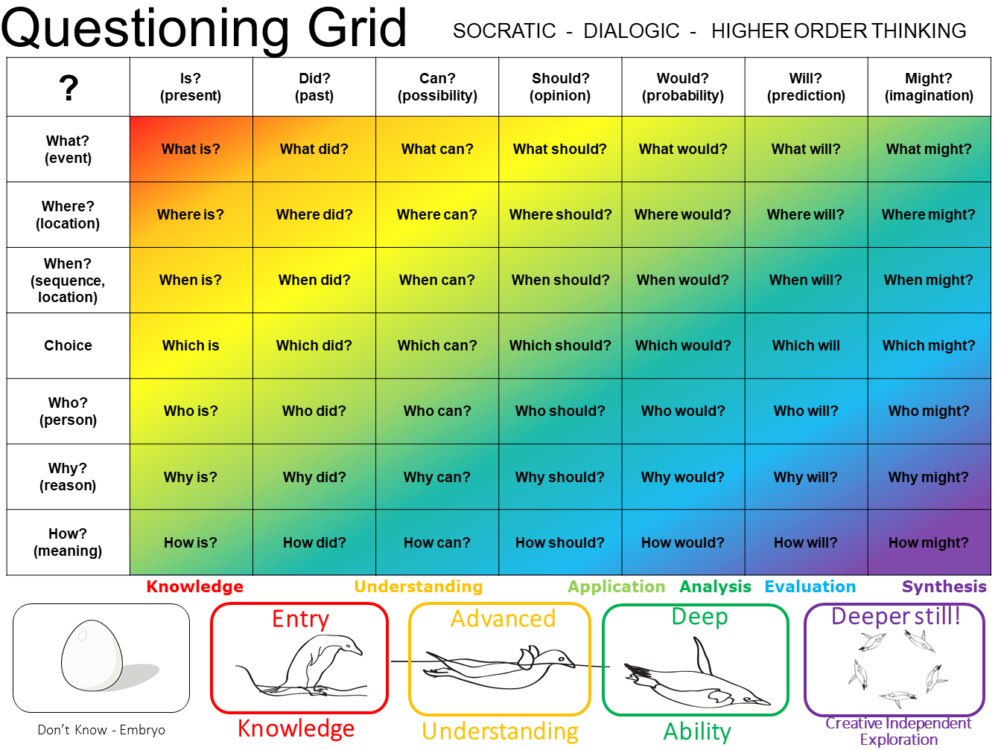
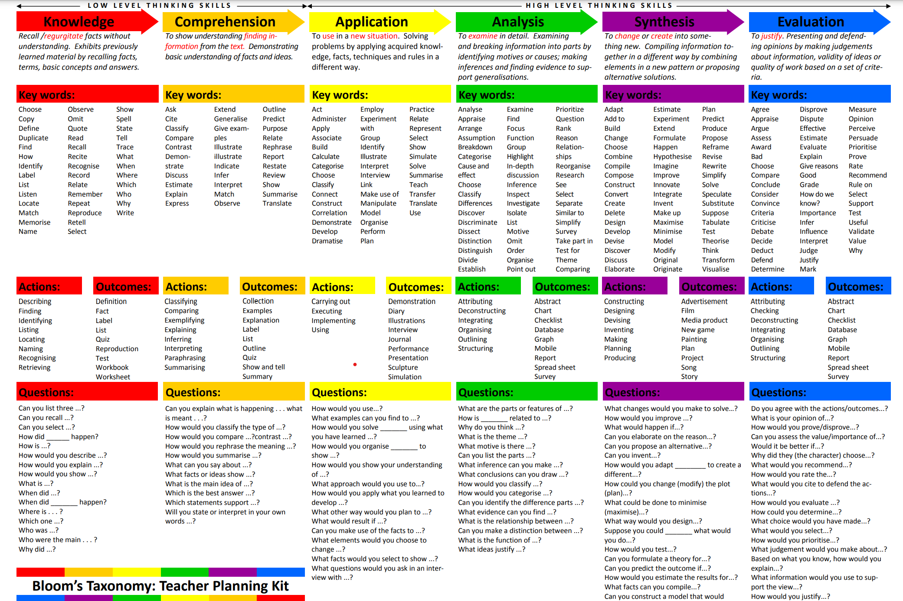

Appendix 2

Springcroft Primary School
EYFS Outcomes and National Curriculum Levels to Point Scores

EYFS
Age Bands | Birth to 3 |  | 3-4 Years |  | Reception |  | ELG
Position in Age Bands | Emerging | Expected | Emerging | Expected | Emerging | Expected | Emerging | Expected | Exceeding
APS | 3.0 | 3.5 | 4.0 | 4.5 | 5.0 | 5.5 | 6.0 | 6.5 | 7.0

- 4 Steps over Foundation Stage is expected progress, typically 2 steps per academic year
- 3 Steps over Foundation Stage is better than expected progress

EYFS On track national achievement throughout the year based on age related expectations

Year Group |  | Baseline | End of  Autumn 2 | End of Spring 2 | End of  Summer 2
Nursery | On track+ | Birth – 3 em  (3.5) | Birth – 3 exp  (3.5) | 3-4 Years em  (4) | 3-4 Years exp  (4.5)
 | HA | Birth – 3 exp  (3.5) | 3-4 Years em  (4) | 3-4 Years exp  (4.5) | Reception em  (5)
Reception | On track+ | 3-4 Years exp  (4.5) | Reception em  (5) | Reception exp/ELG em  (5.5/6) | ELG  exp (6.5)
 | HA | Reception em  (5.0) | Reception exp/ELG em  (5.5/6) | ELG  exp (6.5) | ELG  exc  (7)

APS 7/Exceeding ELG feeds into KS1 APS scores

KS1 – Levels/APS scores

1D  7 | 1D+  8 | 1D++  9 | 1S  10 | 1S+  11 | 1M  12 | 2D  13 | 2D+  14 | 2D++  15 | 2S  16 | 2S+  17 | 2M  18 | 3D  19 | 3D+  20 | 3D++  21 | 3S  22 | 3S+  23 | 3M  24

Year 1
1D  7 | 1D+  8 | 1D++  9 | 1S  10 | 1S+  11 | 1M  12

- 4 steps per year is expected progress (D – S+)
- 5+ steps per year is better than expected progress
Year 2
2D  13 | 2D+  14 | 2D++  15 | 2S  16 | 2S+  17 | 2M  18

- 4 steps per year is expected progress (D – S+)
- 5+ steps per year is better than expected progress

KS1 On track national achievement throughout the year based on age related expectations
Year Group |  | Baseline | End of  Autumn 2 | End of Spring 2 | End of  Summer 2
Year 1 | On track+ | 1D  (7) | 1D+  (8) | 1D++  (9) | 1S+  (11)
 | HA | 1D  (7) | 1D++  (8) | 1S+  (11) | 1M  (12)
Year 2 | On track+ | 2D  (13) | 2D+  (14) | 2D++  (15) | 2S+  (17)
 | HA | 2D  (13) | 2D++  (14) | 2S+  (16) | 2M  (18)
*Expected progress is 3 points over an academic year

KS2 - – Levels/APS scores
Lower KS2
3D  19 | 3D+  20 | 3D++  21 | 3S  22 | 3S+  23 | 3M  24 | 4D  25 | 4D+  26 | 4D++  27 | 4S  28 | 4S+  29 | 4M  30

Year 3
3D  19 | 3D+  20 | 3D++  21 | 3S  22 | 3S+  23 | 3M  24

- 4 steps per year is expected progress (D – S+)
- 5+ steps per year is better than expected progress
Year 4
4D  25 | 4D+  26 | 4D++  27 | 4S  28 | 4S+  29 | 4M  30

- 4 steps per year is expected progress (D – S+)
- 5+ steps per year is better than expected progress

Upper KS2
5D  31 | 5D+  32 | 5D++  33 | 5S  34 | 5S+  35 | 5M  36 | 6D  37 | 6D+  38 | 6D++  39 | 6S  40 | 6S+  41 | 6M  42

Year 5
5D  31 | 5D+  32 | 5D++  33 | 5S  34 | 5S+  35 | 5M  36

- 4 steps per year is expected progress (D – S+)
- 5+ steps per year is better than expected progress
Year 6
6D  37 | 6D+  38 | 6D++  39 | 6S  40 | 6S+  41 | 6M  42

- 4 steps per year is expected progress (D – S+)
- 5+ steps per year is better than expected progress

KS2 On track national achievement throughout the year based on age related expectations
Year Group |  | Baseline | End of  Autumn 2 | End of Spring 2 | End of  Summer 2
Year 3 | On track+ | 3D  (19) | 3D+  (20) | 3D++  (21) | 3S+  (23)
 | HA | 3D  (19) | 3D++  (21) | 3S+  (23) | 3M  (24)
Year 4 | On track+ | 4D  (25) | 4D+  (26) | 4D++  (27) | 4S+  (29)
 | HA | 4D  (25) | 4D++  (27) | 4S+  (29) | 4M  (30)
Year 5 | On track+ | 5D  (31) | 5D+  (32) | 5D++  (33) | 5S+  (35)
 | HA | 5D  (31) | 5D++  (33) | 5S+  (35) | 5M  (36)
Year 6 | On track+ | 6D  (37) | 6D+  (38) | 6D++  (39) | 6S+  (41)
 | HA | 6D  (37) | 6D++  (39) | 6S+  (41) | 6M  (42)
*Expected progress is 3 points over an academic year

Standardised Scores – Springcroft Grades
Autumn Data Point
Standardised Scores (NfER, SATs, etc) | Springcroft Grades | Age Related Expectation | White Rose Maths End of unit/term percentage
 | Previous years D (guide) | WTS | <3%
-79 | Previous years D+ | WTS | 3% - 19%
80-87 | Previous years D++ | WTS | 20% - 36%
88-95 | D | WTS | 37% - 53%
96-109 | D+ | ARE | 54% - 70%
110+ | D++ (S with evidence in books) | GDS | 71% +

Spring Data Point
Standardised Scores (NfER, SATs, etc) | Springcroft Grades | Age Related Expectation | White Rose Maths percentage
-79 | Previous years D++ | WTS | 3% - 19%
80-87 | D | WTS | 20% - 36%
88-95 | D+ | WTS | 37% - 53%
96-109 | D++ | ARE | 54% - 70%
110+ | S (S+ with evidence in books) | GDS | 71% +

Summer Data Point
Standardised Scores (NfER, SATs, etc) | Springcroft Grades | Age Related Expectation | White Rose Maths percentage
-79 | D | WTS | 3% - 19%
80-87 | D+ | WTS | 20% - 36%
88-95 | D++ | WTS | 37% - 53%
96-109 | S | ARE | 54% - 70%
110+ | S+ (M with evidence in books) | GDS | 71% +

Points to note:
- When a child hits S (secure) from the previous year, the data recording becomes D (developing) for the next academic year e.g. A child enters Year 6 at Y5D+ and achieves Y5S at the Autumn data point of Year 6 is recorded as Y6D
- If a child moves from their previous year as s (secure), they transition to become d (developing) in their current academic year group e.g. Y5S at summer term starts Year 6 as Y6D in September.
- The “tracking achievement through the year” grids above gives guidance to what an “ARE” child should achieve throughout the academic year.
- Triangulation of evidence from teacher judgement, consistent work in books, pupil voice and NFER/SAT/WRM assessments should be used to make accurate judgements which are moderated in house as well as externally.

